LAB 6

1)

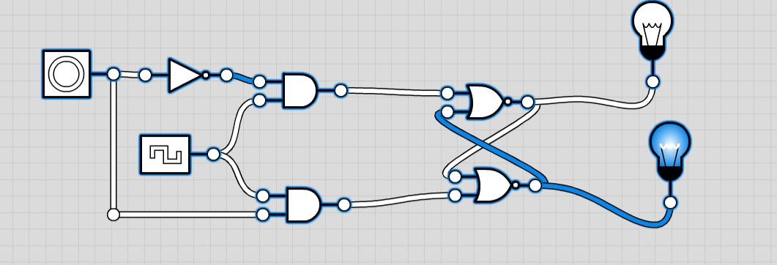

Truth table

|  |  |  |  |
| --- | --- | --- | --- |
| D | Clk | Q | Q+ |
| 0 | 0 | 0 | 0 |
| 0 | 0 | 1 | 1 |
| 0 | 1 | 0 | 0 |
| 0 | 1 | 1 | 0 |
| 1 | 0 | 0 | 0 |
| 1 | 0 | 1 | 1 |
| 1 | 1 | 0 | 1 |
| 1 | 1 | 1 | 1 |

In the case where D and Clk are 0 and Q is 1 making Q+ 1is a situation that doesn’t occur naturally it is also the case when D is 1 and Clk and Q are 0 making Q+ 0. These two situation deviate from Q+ being the same as D.

2)

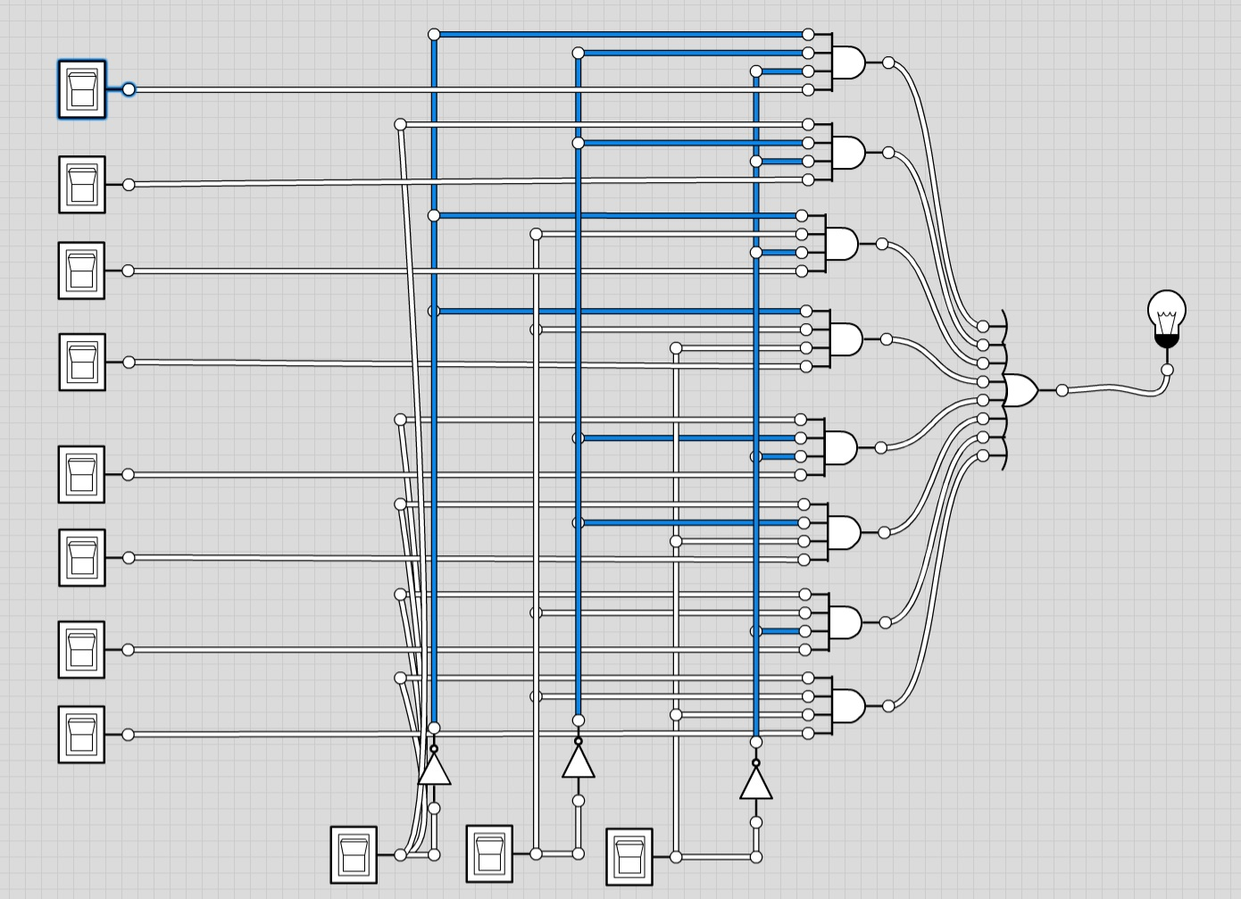

Truth table

|  |  |  |  |
| --- | --- | --- | --- |
| S2 | S1 | S0 | Y |
| 0 | 0 | 0 | X0 |
| 0 | 0 | 1 | X1 |
| 0 | 1 | 0 | X2 |
| 0 | 1 | 1 | X3 |
| 1 | 0 | 0 | X4 |
| 1 | 0 | 1 | X5 |
| 1 | 1 | 0 | X6 |
| 1 | 1 | 1 | X7 |

3)

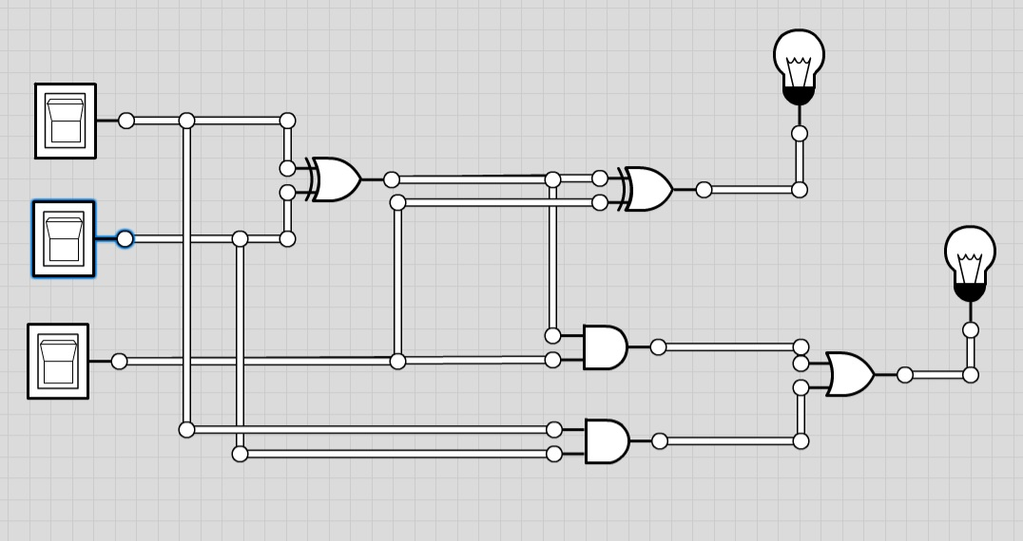

Truth table

|  |  |  |  |  |
| --- | --- | --- | --- | --- |
| Bit 1 | Bit 2 | Cin | X | Cout |
| 0 | 0 | 0 | 0 | 0 |
| 0 | 0 | 1 | 1 | 0 |
| 0 | 1 | 0 | 1 | 0 |
| 0 | 1 | 1 | 0 | 1 |
| 1 | 0 | 0 | 1 | 0 |
| 1 | 0 | 1 | 0 | 1 |
| 1 | 1 | 0 | 0 | 1 |
| 1 | 1 | 1 | 1 | 1 |